**R ASSIGNMENT 2**

#Q1A

chest <- c(rep("gold",20),rep("silver",30),rep("bronze",40))

event <- sample(x=chest,size=10)

print(event)

OUTPUT



#Q1B

print(sample(c("success","failure"),10,replace=T,prob=(c(0.9,0.1))))

OUTPUT



#Q2A

k = 2 # number of people in room

p <- numeric(k)

for (i in 1:k) {

q <- 1 - (0:(i - 1))/365

p[i] <- 1 - prod(q) }

prob <- p[k]

print(prob)

OUTPUT



#Q2B

M=365

for (j in 1:M){

k = j

p <- numeric(k)

for (i in 1:k) {

q <- 1 - (0:(i - 1))/365

p[i] <- 1 - prod(q) }

prob <- p[k]

if(prob>0.5){

break

}

}

print(prob)

print(k)

OUTPUT



#Q3

BayesTheorem = function(P_A, P_B, P_BA) {

P_AB = P_A * P_BA / P_B

return(P_AB)

}

cloudy = 0.40

rain = 0.20

cloudy_rain = 0.85

print(BayesTheorem(cloudy, rain, cloudy_rain))

OUTPUT



#Q4

library(datasets)

print(head(iris)) # first few rows

print(str(iris)) #structure

print(iris$Sepal.Length) #Range

print(mean(iris$Sepal.Length)) #mean

print(median(iris$Sepal.Length)) #median

q=c(quantile(iris$Sepal.Length))#quartiles

print(q[1])

print(q[3])

print(IQR(iris$Sepal.Length)) #interquartile range

print(sd(iris$Sepal.Length)) #std dev

print(var(iris$Sepal.Length)) #variance

print(summary(iris)) #summary

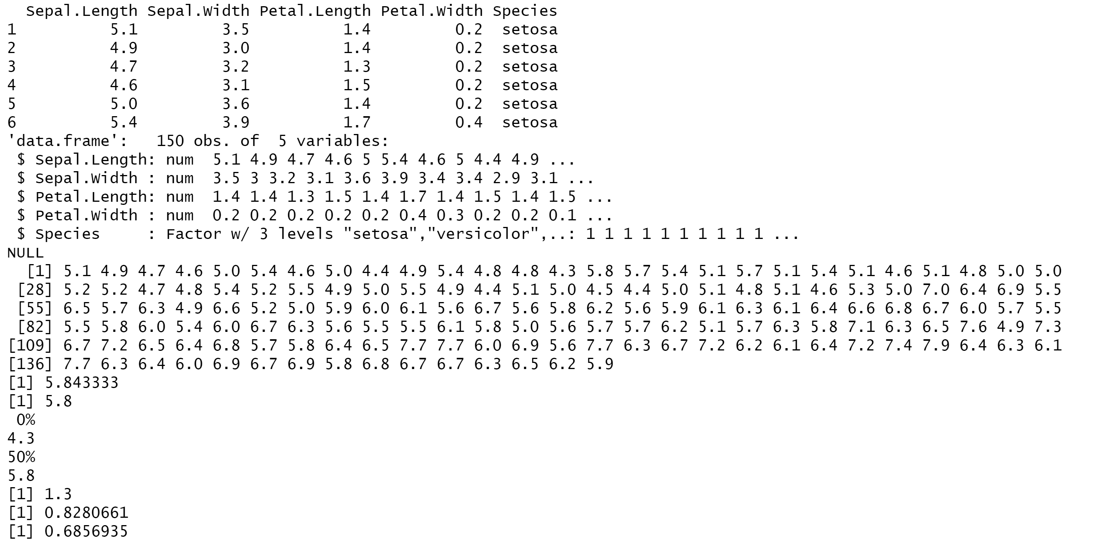

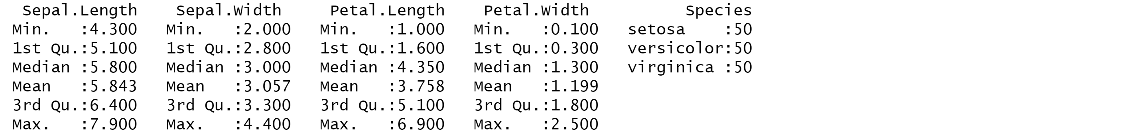

#Q5

getmode <- function(v) {

uniqv <- unique(v)

uniqv[which.max(tabulate(match(v, uniqv)))]

}

v <- c(2,1,2,3,1,2,3,4,1,5,5,3,2,3)

result <- getmode(v)

print(result)

OUTPUT

